# Neo4j Lab

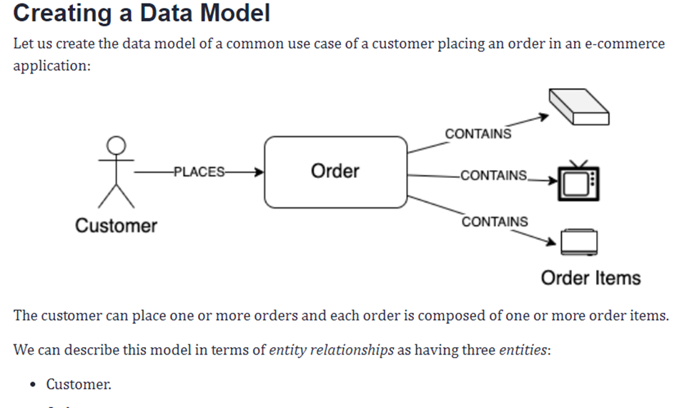

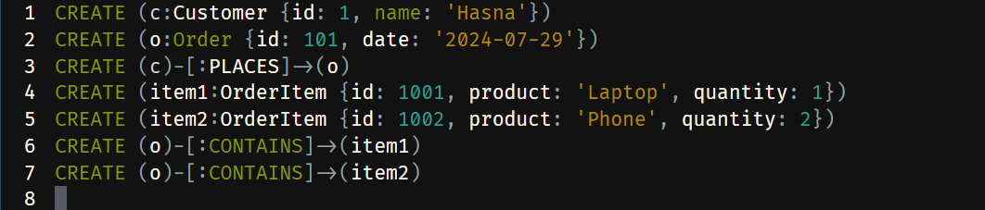

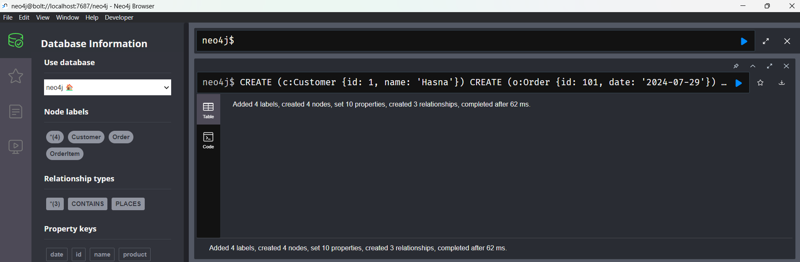

* *one-to-many* relationship between customer and order entities.
* *one-to-many* relationship between order and order item entities.

